Functional Areas

[Learner Name]
School of Business, Technology, and Health Care Administration, Capella University
BHA-FPX3001: Essentials of the Healthcare System
[Courseroom Faculty]
[Month, Day, Year]

QUESTIONS:
- What two functional areas are important to the success of your chosen organization?

First Key Functional Area
[Write 1–2 paragraphs using POETS. Evaluate why you chose the first functional area and include what ethical principles the function needs to be aware of in their day-to-day work. What critical thinking questions would be important to consider to drive company success?]

Second Key Functional Area
[Write 1–2 paragraphs using POETS. Evaluate why you chose the second functional area and include what ethical principles the function needs to be aware of in their day-to-day work. What critical thinking questions would be important to consider to drive company success?]

Grading Rubric-Criterion 2
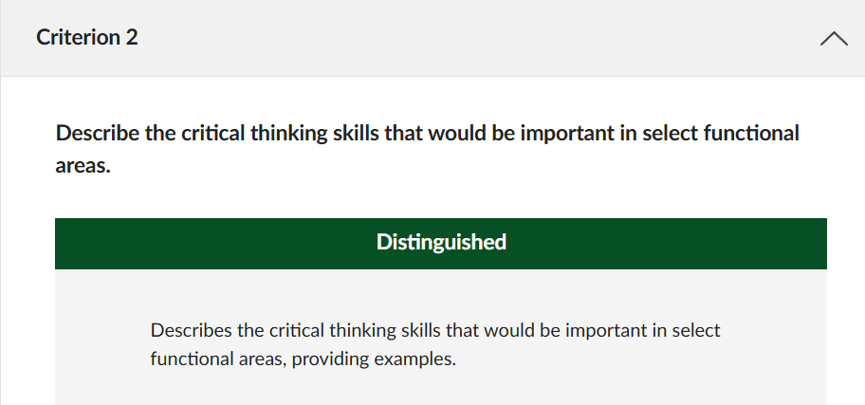

[CHALLENGE: Include a reference list with an attempt at the APA citations, INCLUDING in-text citations.]
References

